**SENSOR LAB MINI PROJECT REPORT**

on

**“PATH FOLLOWING CAR”**

Submitted in partial fulfillment of the requirements of the degree

**BACHELORS OF INFORMATION TECHNOLOGY**

**BY**

### UNDER THE GUIDANCE OF

Guide Name

**UNDER UNIVERSITY OF MUMBAI**

**2022-23**

i

**CERTIFICATE**

This is to certify that the T.E. a sensor lab mini-project entitled “**PATH FOLLOWING CAR**" is a Bonafede work of “student1_name” (rolno) , “student2_name” (rolno), “student3_name"( rolno) and “sturent4” (rolno) submitted to University of Mumbai in partial fulfillment of the requirement for the award of the degree of “Information Technology Engineering” during the academic year 2023-2024.

Mr. Guide_name

[PROJECT GUIDE]

ii

**APPROVAL**

T.E. Mini-Project Report Approval This mini-project synopsis entitled path following car by student1_name, student2_name, student3_name and student4_name is approved for the degree of Information Technology Engineering from University of Mumbai.

***Examiners***

1.----------------------------

2.----------------------------

Date: _ _ _ _ _ _ _ _ _ _ _

Time: _ _ _ _ _ _ _ _ _ _

iii

**Acknowledgement**

This is great pleasure and immense satisfaction to express our deepest sense of gratitude and thanks to everyone who has helped us in completing our work successfully. We are presenting this Project report on **“PATH FOLLOWING CAR”** as part of the curriculum of T.E. Information Technology. Inspiration and guidance are invaluable in every aspect of life especially in the field of academics, which we have received from our respected **Project Guide: Guide_name** and **Head of Information Technology:** HOD_name. Besides, we take this opportunity to express our sincere gratitude to the **Principal:** Principle_name, for providing a good environment and facilities to complete this project. We would also like to thank all our staff and friends who have directly or indirectly guided and helped us in the preparation of this report and also for giving us an unending support right from the stage this idea was conceived.

student1_name

student2_name

student3_name

student4_name

iv

**Abstract**

This project aims to develop a path-following car prototype using an Arduino Uno microcontroller and an L298N motor driver. The car is designed to autonomously navigate along a predefined path using sensors to detect and interpret its surroundings. By integrating Arduino Uno's programming capabilities with the motor driver's control functionalities, the car will be able to adjust its speed and direction based on the input received from the sensors.

The implementation involves configuring the Arduino Uno to interface with various sensors, such as infrared or ultrasonic sensors, to detect obstacles and track the path. The L298N motor driver facilitates the control of the car's motors, allowing for precise adjustments in speed and direction. Through programming logic and algorithm development, the car will follow a predetermined path by continuously analyzing sensor data and making appropriate motor adjustments.

Ultimately, this project aims to demonstrate the potential of Arduino-based systems in creating autonomous vehicles for simple navigation tasks. The combination of Arduino Uno's versatility and the L298N motor driver's robust motor control capabilities provides a solid foundation for developing a path-following car prototype that can pave the way for more advanced autonomous vehicle applications in the future.

V

**CONTENTS**

**Title Page ……………………………………………………………………….. i**

**Certificate ………………………………………………………………………. ii**

**Approval ………………………………………………………………………. ii****i**

**Acknowledgements …………………………………………………………….. iv**

**Abstract …………………………………………………………………………** **v**

**List of Figures ………………………………………………………………….. vi****i**

**List of Abbreviations and Symbols ………………………………………...…. viii**

1. **Introduction …………………………………………………………….**

1.1 Path Following Car ………………………………….………..… 1

1. **Aims and Objective …………………………………………………….**

2.1 Objective ……….…………………………………………… **2**

2.2 Aim ……………………………………………………………. **2**

1. **Problem Statement …………………………………………………… 3**
2. **Proposed System….. …………………………………………………… 4**
3. **Methodology…………………………………………………………..... 5**

5.1 List of component …………………………………………………. . 5

5.2 Circuit diagram …………………………………………………. . 9

5.3 Arduino Code …………………………………………………. . 10

5.4 Flow Chart ……………………………………………………. . 12

1. **Details of Hardware and Software …………………………………… 13**
2. **Advantages …………………………………………………………… 14**
3. **Conclusion ………..……………………………………………………. 15**

**References …………….………………………………………………………….. 16**

**LIST OF FIGURES**

|  |  |  |
| --- | --- | --- |
| **Fig no.** | **Figures** | **Page No.** |
| 4.1 | Block diagram | 7 |
| 4.2 | Model image | 7 |
| 5.1.1 | Arduino UNO | 8 |
| 5.1.2 | L293D Motor Driver | 8 |
| 5.1.3 | BO Motor | 8 |
| 5.1.4 | Li Ion Battery | 9 |
| 5.1.5 | Battery Holder | 9 |
| 5.1.6 | Switch | 9 |
| 5.1.7 | IR Sensor | 10 |
| 5.1.8 | Jumper Wire | 10 |
| 5.2.1 | Circuit Diagram | 11 |
| 5.4.1 | Flow Chart | 12 |

vii

##### LIST OF ABBREVIATIONS

|  |  |  |
| --- | --- | --- |
| **Sr. No** | **Short form** | **Abbreviation** |
| 1 | UNO | Universal Networking Object |

viii

## Introduction

### In the realm of robotics and autonomous systems, the development of vehicles capable of navigating predefined paths autonomously holds significant promise for various applications, from warehouse logistics to agricultural automation. In this context, the project focuses on the creation of a path-following car prototype using accessible hardware components like the Arduino Uno microcontroller and the L298N motor driver. The integration of these components allows for the construction of a simple yet effective platform for experimenting with autonomous navigation algorithms.

### The motivation behind this project stems from the increasing interest in leveraging cost-effective solutions for autonomous vehicle development. By harnessing the computational power of the Arduino Uno and the motor control capabilities of the L298N driver, enthusiasts and researchers alike can explore the fundamentals of autonomous navigation without the need for specialized equipment or extensive resources. This project serves as a practical demonstration of how readily available hardware components can be utilized to prototype autonomous systems, thereby democratizing access to robotics and fostering innovation in the field.

### Through this endeavor, we aim to provide a foundational understanding of autonomous navigation principles and inspire further exploration into the realm of robotics. By introducing concepts such as sensor integration, motor control, and algorithm development within the context of a path-following car, this project sets the stage for enthusiasts to delve deeper into more complex autonomous systems. Ultimately, the insights gained from this project contribute to the broader goal of advancing the field of robotics and accelerating the development of intelligent, autonomous machines for real-world applications.

### Aim & Objectives

* 1. **Objective:**

The first objective is to integrate the Arduino Uno microcontroller with the L293D motor driver to establish a robust hardware platform for motor control and sensor interfacing. This involves connecting the motors to the motor driver and configuring the Arduino Uno to communicate with the motor driver for controlling the car's movement.

Next, the project aims to incorporate sensors, such as infrared or ultrasonic sensors, to enable the car to detect obstacles and accurately follow the predefined path. By integrating these sensors with the Arduino Uno, the car will be able to gather information about its surroundings and make informed decisions about its movement.

Furthermore, the project seeks to develop algorithms to process sensor data and determine the appropriate speed and direction adjustments required for the car to navigate autonomously. These algorithms will enable the car to continuously analyze sensor inputs and make real-time adjustments to its movement to stay on course and avoid obstacles.

* 1. **AIM:**

The primary aim of this project is to design and implement a path-following car prototype using an Arduino Uno microcontroller and an L293D motor driver. This project aims to showcase the feasibility of utilizing accessible hardware components for creating a simple autonomous vehicle capable of navigating predefined paths.

1. **Problem Statement**

The project addresses the challenge of designing a path-following car prototype using an Arduino Uno microcontroller and an L293D motor driver. Integrating these components poses a critical challenge in establishing a robust hardware platform capable of accurately controlling the car's movement. Additionally, the incorporation of sensors, such as infrared or ultrasonic sensors, presents a hurdle in enabling the car to detect obstacles and track the predefined path effectively. Algorithm development is essential to process sensor data and determine the necessary speed and direction adjustments for autonomous navigation. Furthermore, the project must evaluate the prototype's performance under various conditions to ensure its effectiveness and reliability. By tackling these challenges, the project aims to showcase the feasibility of creating accessible and cost-effective autonomous vehicles for navigation tasks.

1. **Proposed System**

IR1

Sensor

Arduino UNO

motor driver shield

Arduino UNO

Motor2

IR2

Sensor

Power Supply

Motor1

***Fig no. 4.1 Block Diagram***

The block diagram illustrates the architecture of a path-following car project using an Arduino Uno microcontroller and an L293D motor driver. At the core of the system is the Arduino Uno, which receives input from sensors and sends control signals to the motor driver. Sensors, such as infrared or ultrasonic sensors, detect obstacles and track the path. The motor driver regulates the speed and direction of the DC motors, which propel the car. A power supply unit provides the necessary voltage and current for stable operation. Overall, the diagram depicts how these components work together to enable autonomous navigation of the path-following car.

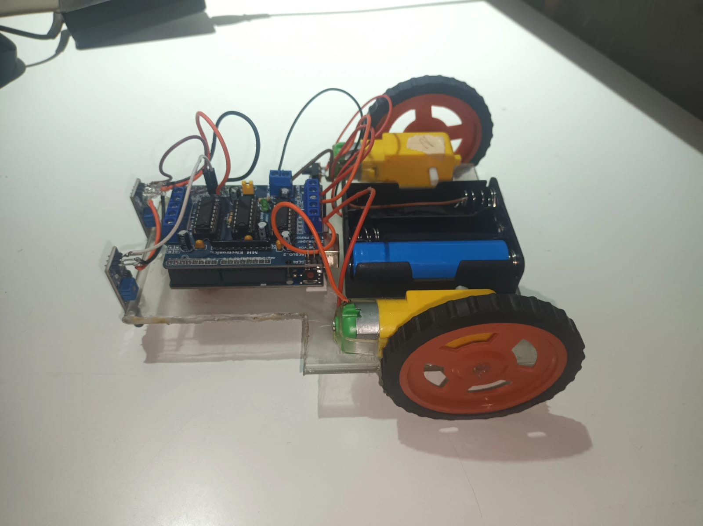

***Fig no. 4.2 model image***

1. **Methodology**

**5.1 List of components**

1. Arduino UNO

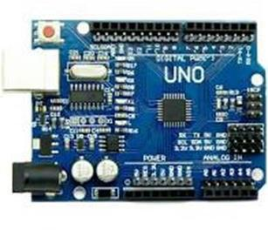

***Fig no 5.1.1 Arduino UNO***

Arduino Uno is an open-source microcontroller board that can be programmed to control various electronic devices and systems. In the context of a path following car, Arduino Uno can be used as the main processing unit to control the sensors and actuators of the device.

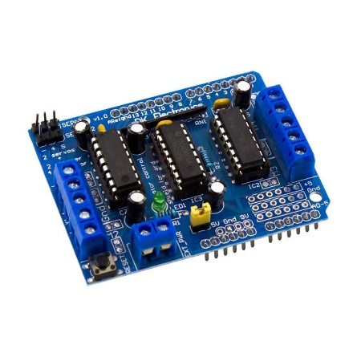

***Fig no 5.1.2 L293D motor driver***

The L293D motor driver is a popular integrated circuit used to control the speed and direction of DC motors. It provides a convenient solution for interfacing motors with microcontrollers like Arduino. The L293D can drive two DC motors independently or one stepper motor, making it versatile for various robotics and automation projects. It features built-in protection diodes to prevent damage from motor back EMF and can handle motor currents up to 600mA per channel (1.2A peak). With its straightforward interface and robust capabilities, the L293D motor driver is widely used in hobbyist and educational projects for controlling motorized systems with ease.

1. BO Motor

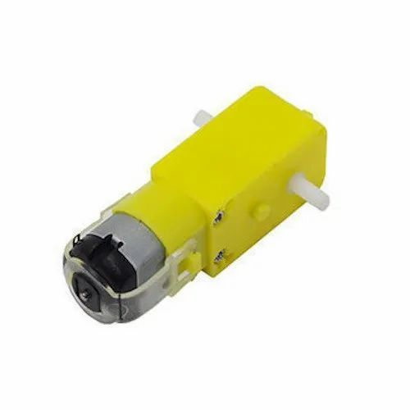

***Fig no 5.1.3 Bo Motor***

A BO (Brushed DC) motor, short for "Brushed Direct Current" motor, is a type of electric motor commonly used in robotics, automation, and hobbyist projects. It consists of a rotating armature (the rotor) and stationary magnets (the stator). The rotor is connected to a shaft that rotates when a current is applied to the motor's brushes, creating electromagnetic interactions between the rotor and stator, resulting in motion.

1. LED

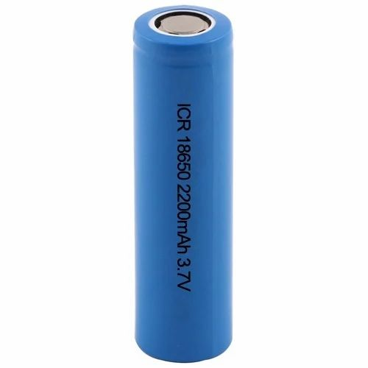

***Fig no 5.1.4 Li ion Battery***

Li-ion (Lithium-ion) batteries serve as an ideal power source for the path-following car project due to their advantageous characteristics. Their high energy density allows for the storage of a significant amount of energy in a compact and lightweight form, ensuring that the car remains agile and maneuverable while carrying its power source. This aspect is particularly crucial for a project like the path-following car, where mobility and efficiency are paramount. Additionally, Li-ion batteries come in various voltage and capacity ratings, enabling users to select the appropriate battery pack based on the project's power requirements, ensuring compatibility with the motors and electronics of the car.

1. Battery Holder

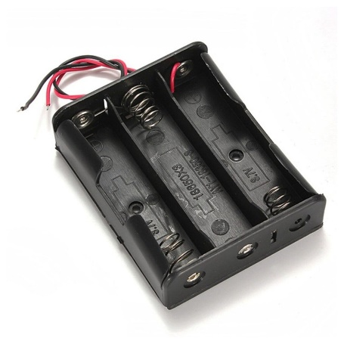

***Fig no 5.1.5 Battery Holder***

A 3 Li-ion battery holder provides a convenient and reliable solution for powering the path-following car project with multiple Li-ion batteries. These battery holders are designed to securely hold and connect three individual Li-ion batteries, offering several advantages for the project

1. Switch

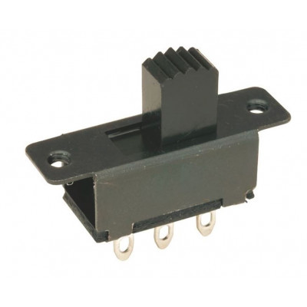

***Fig no 5.1.6 Switch***

A Single Pole Double Throw (SPDT) slide switch is a type of electrical switch that controls the flow of current in a circuit by allowing the user to toggle between two different connections. Here's how it relates to your project

1. IR Sensor

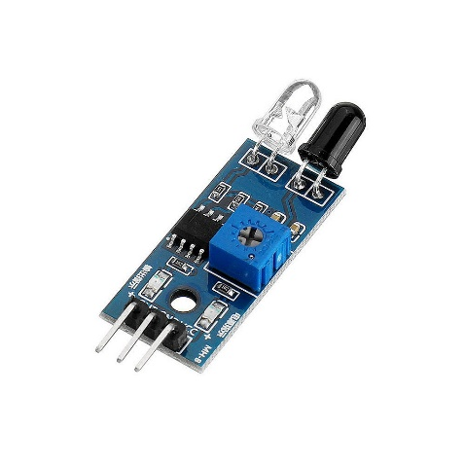

***Fig no 5.1.7 Switch***

Infrared (IR) sensors are fundamental components for your path-following car project, serving as the eyes of the vehicle to perceive its environment. These sensors emit infrared light and measure the intensity of the light reflected back from nearby objects. This capability enables the car to detect obstacles in its path, crucial for ensuring safe and obstacle-free navigation. By strategically placing IR sensors around the car's chassis, it can effectively sense obstacles from various directions and adjust its trajectory to avoid collisions. Moreover, IR sensors can be utilized for line following, a common technique where contrasting lines on the ground guide the car along a predefined path.

1. Jumper Wire

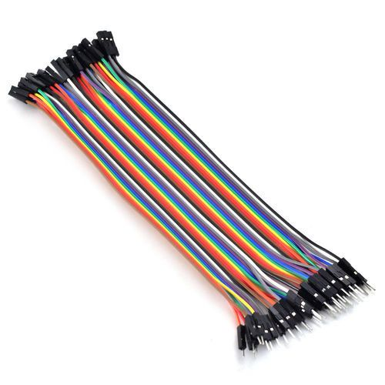

***Fig no 5.1.8 Jumper Wire***

Jumper wires are essential components for your path-following car project, facilitating the connection between various electronic components such as sensors, motor drivers, and the Arduino microcontroller. These wires, typically made of flexible insulated material with metal connectors at each end, allow for quick and easy prototyping and experimentation without the need for soldering

**5.2 Circuit diagram**

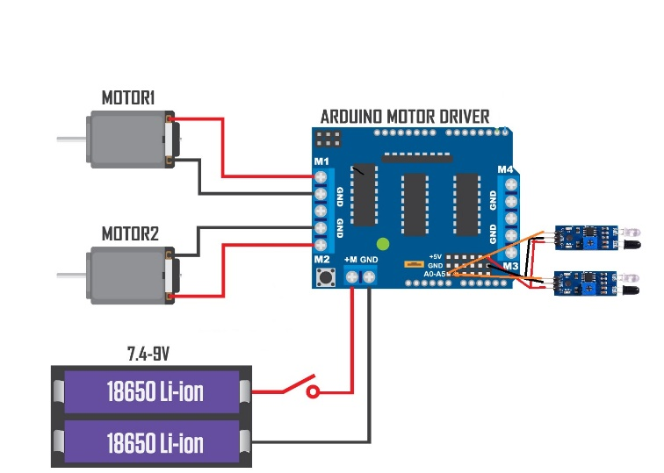

***Fig no. 5.2.1 Circuit Diagram***

The circuit diagram for your path-following car project incorporating IR sensors offers a detailed illustration of the electrical connections necessary for its functionality. Positioned centrally in the diagram is the Arduino Uno microcontroller, functioning as the brain of the system. Surrounding the Arduino are symbols representing IR sensors, strategically positioned to detect obstacles and navigate the car along its predefined path. These sensors provide crucial environmental feedback to the Arduino, enabling it to make real-time decisions about the car's movement. The connections between the IR sensors and the Arduino are depicted, indicating how sensor data is transmitted to the microcontroller for processing.

Adjacent to the IR sensors are symbols representing the L293D motor driver, responsible for controlling the car's DC motors. The motor driver interfaces with the Arduino, receiving commands to adjust the motors' speed and direction based on the sensor inputs. Symbols representing DC motors are connected to the motor driver outputs, illustrating how they receive signals to drive the car's movement. Additionally, a power supply symbol is included, providing voltage to power the entire system, ensuring uninterrupted operation.

The lines connecting the components in the diagram illustrate the flow of signals and power, guiding the construction process and ensuring proper connectivity. Overall, the circuit diagram serves as a comprehensive guide for assembling the electrical infrastructure of the path-following car, facilitating seamless integration of its various components and enabling autonomous navigation based on IR sensor feedback.

### 5.3 Arduino program

//including the libraries

#include <AFMotor.h>

//defining pins and variables

#define left A0

#define right A1

//defining motors

AF_DCMotor motor1(1, MOTOR12_1KHZ);

AF_DCMotor motor2(2, MOTOR12_1KHZ);

AF_DCMotor motor3(3, MOTOR34_1KHZ);

AF_DCMotor motor4(4, MOTOR34_1KHZ);

void setup() {

//declaring pin types

pinMode(left,INPUT);

pinMode(right,INPUT);

//begin serial communication

Serial.begin(9600);

}

void loop(){

//printing values of the sensors to the serial monitor

Serial.println(digitalRead(left));

Serial.println(digitalRead(right));

//line detected by both

if(digitalRead(left)==0 && digitalRead(right)==0){

//Forward

motor1.run(FORWARD);

motor1.setSpeed(90);

motor2.run(FORWARD);

motor2.setSpeed(90);

}

//line detected by left sensor

else if(digitalRead(left)==0 && !analogRead(right)==0){

//turn right

motor1.run(FORWARD);

motor1.setSpeed(180);

motor2.run(BACKWARD);

motor2.setSpeed(160);

}

//line detected by right sensor

else if(!digitalRead(left)==0 && digitalRead(right)==0){

//turn left

motor1.run(BACKWARD);

motor1.setSpeed(160);

motor2.run(FORWARD);

motor2.setSpeed(120);

}

//line detected by none

else if(!digitalRead(left)==0 && !digitalRead(right)==0){

//stop

motor1.run(RELEASE);

motor1.setSpeed(0);

motor2.run(RELEASE);

motor2.setSpeed(0);

}

}

* 1. **Flowchart**

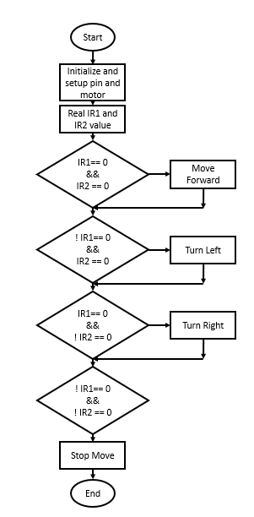

***Fig no. 5.4.1 Flowchart***

1. **Hardware and software**
2. Hardware:

System : Intel Core i3 2.00 GHz.

Disk : 1 TB.

Monitor : 14’ Color Monitor.

Mouse : Mouse.

Ram : 2 GB.

Keyboard : Keyboard.

1. Software:

Operating system : Windows 10.

Coding Language : C, CPP

Software’s used : Arduino IDE.

## Advantages

The project demonstrates the capability to create a vehicle that can navigate autonomously along predefined paths. This technology has numerous practical applications, such as in warehouse logistics, surveillance, and automated guided vehicles (AGVs).

Utilizing readily available components like Arduino Uno microcontroller, IR sensors, and DC motors, the project offers a cost-effective solution for experimenting with autonomous vehicle technology. This affordability makes it accessible to hobbyists, students, and enthusiasts interested in robotics and automation.

The project provides an excellent educational opportunity to learn about electronics, programming, and robotics. By building and programming the path-following car, individuals can gain hands-on experience with sensor integration, motor control, algorithm development, and troubleshooting, enhancing their skills in STEM (Science, Technology, Engineering, and Mathematics) fields.

### Conclusions

In conclusion, the path-following car project utilizing IR sensors and Arduino Uno microcontroller offers a compelling blend of practicality, affordability, and educational value. By creating a vehicle capable of autonomous navigation along predefined paths, the project demonstrates the potential of accessible technology to address real-world challenges in robotics and automation. Through the integration of readily available components and the implementation of sophisticated algorithms, individuals gain valuable hands-on experience in sensor integration, motor control, and algorithm development, fostering skills in STEM fields and promoting innovation and creativity. Furthermore, the project's cost-effectiveness and customizability make it accessible to a wide range of enthusiasts, providing opportunities for exploration and experimentation in robotics and autonomous systems. Overall, the path-following car project not only showcases the capabilities of modern technology but also inspires curiosity, learning, and engagement, making it a rewarding and worthwhile endeavor for enthusiasts of all backgrounds.

**References**

[1] B. Briseño-Tepepa, E. Palacios and H. Rodriguez-Cortes, "Path following through reference points for a car-like mobile robot," 2011 8th International Conference on Electrical Engineering, Computing Science and Automatic Control, Merida City, Mexico, 2011, pp. 1-6, doi: 10.1109/ICEEE.2011.6106568.

[2] Laghrouche, Salah & Harmouche, Mohamed & Chitour, Yacine. (2013). Target-point based path following controller for car-type vehicle using bounded feedback. Proceedings of the IEEE Conference on Decision and Control. 10.1109/CDC.2012.6426126.

[3] Kumar Jha, Sujeet & Karn, Manish & Khan, Ahmed. (2016). PROJECT REPORT LINE FOLLOWING ROBOT.

[4] YouTube: <https://youtu.be/t7k9D1jDEtk?si=_4Cxm_MloBEmR0oU>

[5] Autodesk Instructible: <https://www.instructables.com/Line-Follower-Robot-Arduino-and-L293D-Shield/>